30 years of listening on the 80m band
Jonathan Hare, G1EXG
I got the electronics and radio bug in the 1980’s. I had an amazing science teacher (Capt. Reese James) who introduced me to electronics. He ran a science club at school where we could make our own ZN414 chip radios. Dad would often drop me off at GWM Radio (Portland Road, Worthing) on Saturday mornings, safe in the knowledge that I would be entertained for several hours while he went around town. When it came time to pay for my large bag of 'bits and pieces' the kindly man behind the counter always said "50p?" ... which was of course exactly what I had as pocket money!
For me a great draw of amateur radio was the way it explored the world with homemade gear. I still love making things to explore nature. I started to build radios and in the process I ‘discovered’ the 80m band. 80m has been a constant companion ever since. I've grown up with the 80m band. It was a virtual world before the internet or 'world wide web'. Over the years I got to know the subtleties and peculiarities of the band and the characters who like to spend time on this small part of the spectrum - the 80m band 'community'.

The 80m band
80m is a great short wave band because there is nearly always something interesting to listen to. In the day time you have a lot of UK stations chatting, in the evening European wide contacts can be heard and at night and early morning long distance (DX) worldwide communications can be heard. Although 80m can be a DX band at anytime of the year (at night) it is generally best in the early hours in winter. The 80m band is a superb band to start short wave listening because home-made equipment can be made fairly easily.

My first communications receiver – the MK I DC Rx
My first experience of amateur radio was using an old Nimco valve radio (it was a marine radio that would work with 240V AC or DC) with a homemade BFO to resolve the CW and SSB stations. I then moved on to make my own ‘communications receiver’. My MK I 1980's set-up (see photos) included the following home-made gear: direct conversion receiver (DC Rx), BPF audio filter, pre-selector, inverted V (full sized 80m dipole), ATU and a pair of SG Brown high Z headphones.

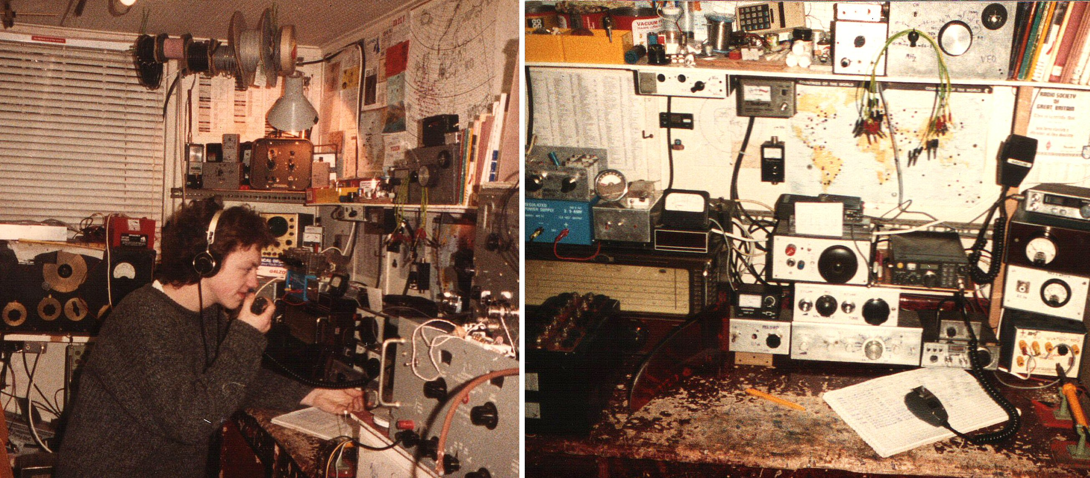
The author in his radio room late 1980’s. I joined the RSGB in 1982 (RS51632) then in 1984 I became G1EXG. The radio on the table top, just above the log book on the right hand photo, is the 80m DC Rx MK I, see close-up photo below.

The DC Rx was based on the one outlined in Pat Hawkers - A Guide to Amateur Radio [1]. I modified the audio circuit to include a homebrew speech processor circuit. This was designed to be used between a microphone and transmitter but I found it worked well as a band pass filter (BPF) preamplifier to drive the high impedance headphones. I used a beautiful brass Jackson reduction drive I salvaged from an old piece of test equipment. This little MK I radio got me hooked on 80m. From November 1982 to January 1987 I heard 106 countries on the 'top’ (the DX) end of 80m - it taught me geography!

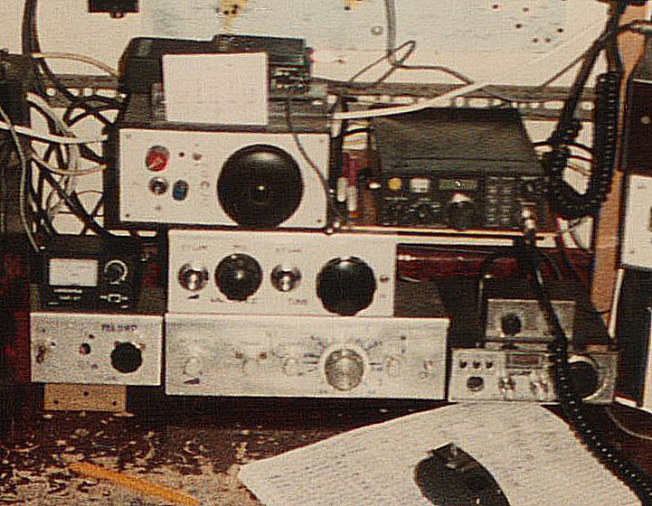
My radio gear in the late 1980’s. Top row: DC Rx for 10m next to my 2m band FT290R, second row: SWR meter and 40m DC Rx, bottom row: 80m pre-selector, the 80m MK I DC Rx and on the right a 20m DC Rx. All homemade gear (apart from the FT290R and SWR meter).

The first time you can hear the twang of accent on a weak ZL or VK station on equipment you have made is a really wonderful experience. This radio also won me the 1983 Worthing and District Amateur Radio club constructional contest!

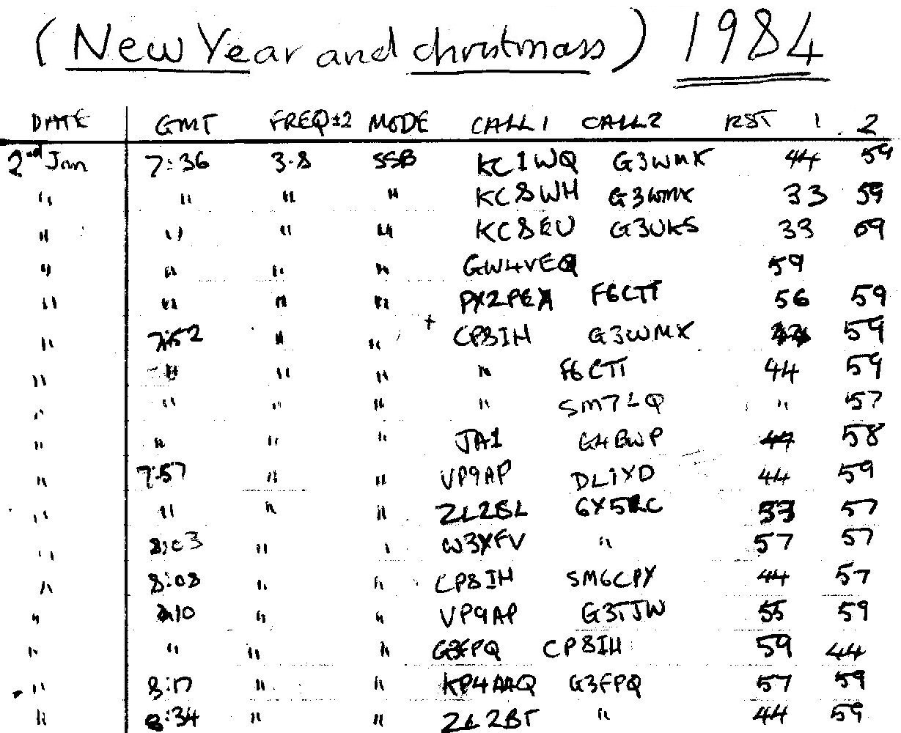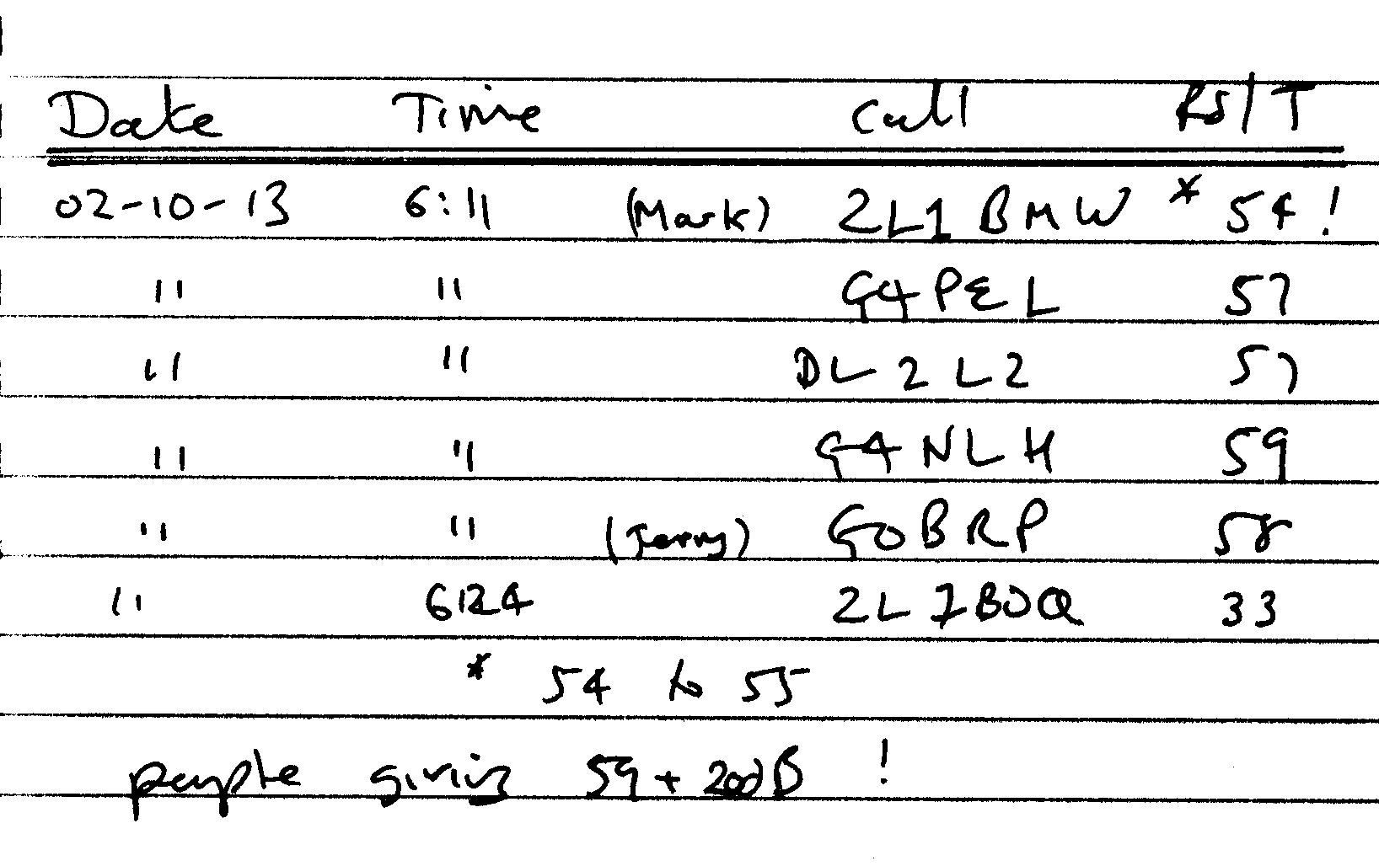
Two SSB 80m log book entries: i) around Christmas 1984, ii) and Oct 2013

Signal Reports
Exploring the radio frequencies with a relatively simple homemade radio (with no AGC, see later) and no S-meter) means you learn to listen. You develop 'safe cracking’ fingers on the tuning knob, ‘peaking’ skills on the pre-selector controls and the imagination to 'guess' what the faint signal in the noise is trying to say! In my receiver logbook I only ever give a 59 to ‘local’ / UK stations. 59 means a very strong signal which can be perfectly copied. If you don t have an S-meter then the signal report defines how strong the signal is compared to the noise (or other interference). So when I heard ZL1BMW this year and gave him a 54, for me it was a really 'good' report for a DX station. I know others in the UK were giving him 59 + 20dB but as I could also hear the noise of the band 'around' him and the crash and bangs of distant lightening, there is no way I would log him as 59 ... even if an S-meter might say ‘many dB’s over S9’.

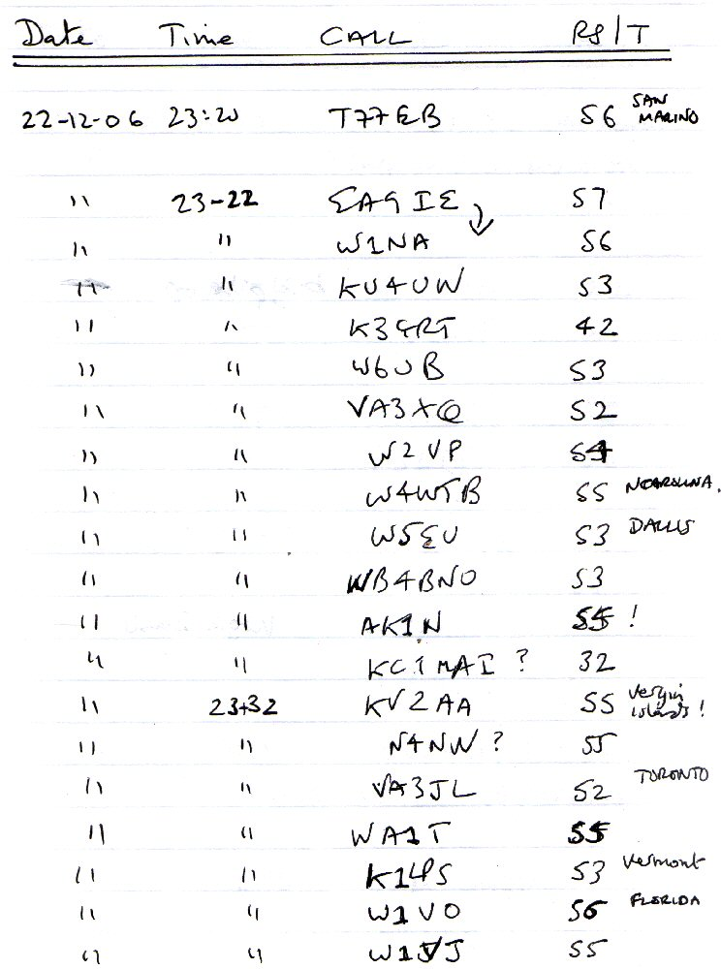
80m Log book entries for Dec 2006: EA9IE works a lot of Northern America
… and I can hear it all as well!
MK II design
I learnt a lot from the MK I DC Rx and so based on this experience in 2002 I built a MKII version. This had a better front end BPF: two back to back tuned circuits with as small a coupling as I could get away with and still get a signal through! It uses a NE602 double balanced mixer driving a differential pre-amplifier and audio stage with BPF. I made the radio with a decent amplifier so it could drive low Z headphones but also taped on the volume control to drive the high Z if needed. I also included a 20m front end-mixer stage so I can switch between the two bands.

Pre-selector
A simple one transistor (FET) pre-amplifier with tuned circuits on the input and output can make a very useful pre-selector. This gives a useful 10 to 15dB of RF gain and greatly improves the selectivity of a simple radio and helps reduce break-through problems with strong broadcast stations etc. My version was based on one described in the RSGB’s Radio Electronics cookbook [2] which works really well. I wound the coils just for 80m and a dual-gang cap allows peaking. I wired in a simple antenna switch so I can swap between two antennas and have also included a by-pass switch.
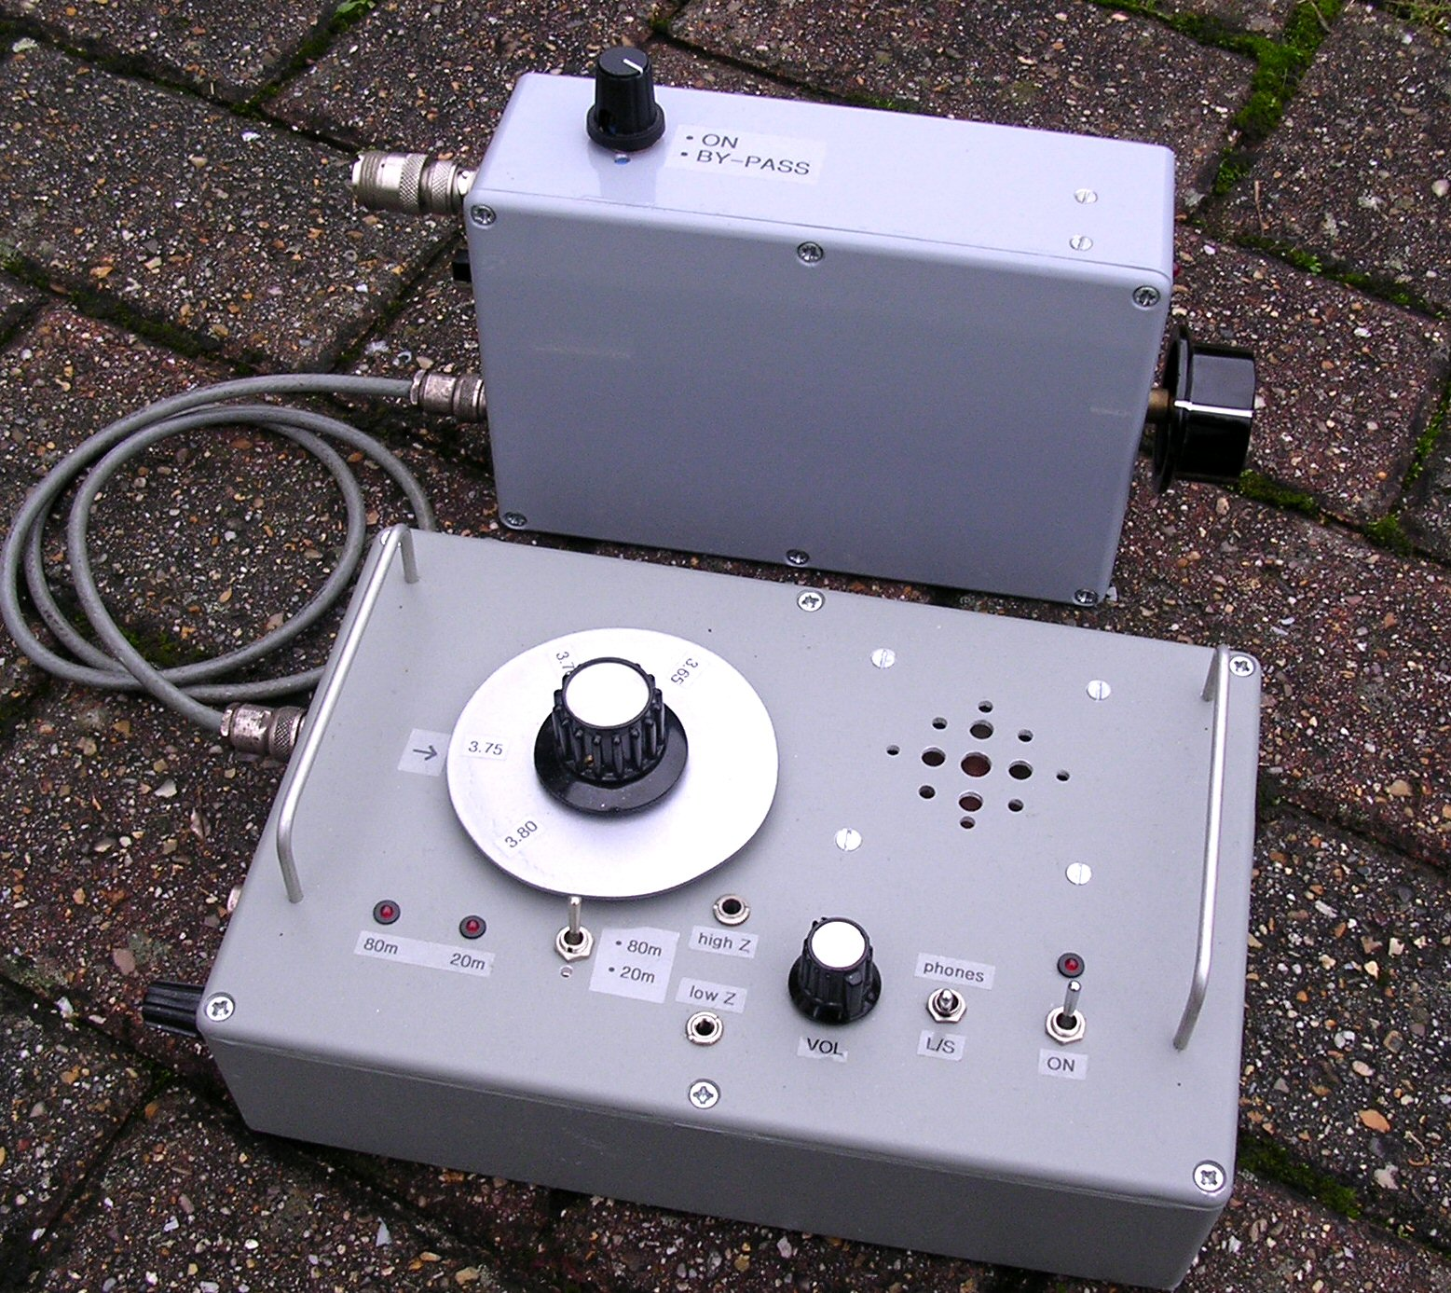
The MK II DC Rx (bottom) with pre-selector (top) ca. 2002

I often use a headphones splitter cable so that I can also plug in small MP3 recorder. This way I can record DX. Archos used to make a very useful battery powered MP3 player that takes a 3.5 mm stereo jack input so you can make MP3 recordings (Archos Ondio). Note: some switch mode power supplies are noisy so a battery powered recorder is preferred.

Some notes on (DC) direct conversion receivers
If you want to make a radio just for a single band, say 80m, then a Direct Conversion (DC) receiver are a lot easier to set up and get working well than a super-het device. With a good choice of mixer and audio strip you can make a sensitive and selective radio. There was a useful article in Rad Com a few years ago about perfecting DC receivers [3].
My dual conversion super-het IC706 transceiver is definitely better than my MKII DC Rx - but it’s not far off (about the same as the 706 with its 10dB attenuator in-line). A drawback of a DC receiver is that because the mixer o/p is at audio frequencies at any spot frequency you can in principle hear two frequencies at once. This is because both sidebands around a carrier can be resolved by a DC receiver. So for example if a DC Rx is tuned to 3.75 MHz it could in principle hear an identical 1 kHz CW tone if a CW transmission was at 3.750 + 0.001 = 3.751 MHz or at 3.750 - 0.001 = 3.749 MHz. So a DC Rx appears to have 'twice' the receive bandwidth of a comparable super-het. This can make a busy ‘top end’ of 80m seem even busier!
Another problem with DC Rx is that all the main gain of the radio is obtained in the audio amplifier. Now you can add RF gain using a pre-selector (10-15dB) and the NE602 mixer can be configured to have about 5-10dB gain. But basically all the filtering and main gain of the radio gets done at the audio stage (the audio stage is the IF of the DC receiver). So generally you have to use a high gain audio stage. You need to be careful to remove any RF from the mixer o/p to avoid instability problems (audio howling). With so much audio gain it's wise to use a common earth point to minimise hum loops. You have to take extra special care to decouple all the stages of the radio. Battery power is much better than a mains power pack, it greatly reduces hum problems.

No AGC - beware when using headphones!
A simple DR Rx does not have an automatic gain control (AGC). Actually it does - it’s called your hand on the volume control! It can be painful to have no AGC if you are wearing headphones. For example when DF2BO (Tom, a German DX chaser with a very strong signal) is working DX I have to be very careful when he transmits. Why? Because he really is 59 (!) and the sudden loudness of his signal is often quite painful when you have just been mentally ‘tuning’ into a very weak DX signal in the background. A pair of back to back diodes across the H/P might help clip the sudden peak before your reflex kicks-in to turn the volume down.
However the lack of AGC gives the DC Rx a quick response, so you can listen to the DX immediately a strong station stops transmitting. So in that sense a DC Rx is a great CW or small signal SSB radio. I have played around with some designs for a DC Rx AGC using a voltage controlled amplifier ... this is work in progress.
DC Rx often need quite a strong local oscillator drive into the mixer so you have to make sure that none of this radio energy goes back into the antenna. A simple FET buffer input stage can solve this problem.
Finally if you are going to leave an antenna permanently connected to your homemade radio its worth putting a couple of silicon diodes back-to-back on the antenna input. Otherwise the input stage will eventually get ‘fried’ by natural static electricity build-up or nearby lightening. After 9 years using my MKI radio without protection diodes one day I found it rather deaf ... the 2N2819 FET on the input had finally died.

Headphones
The old SG Brown high impedance (high Z) phones had a nice peak in the audio response so it was if they had their own built in CW filter! They also worked fine for SSB as well. I spend so much time listening on these headphones I sometimes wonder if my ears have adjusted their response to match. I seem to be very sensitive to the wheel squeak and brake noise on trains and the London underground ... I sometimes wonder if it’s a legacy of those headphones!

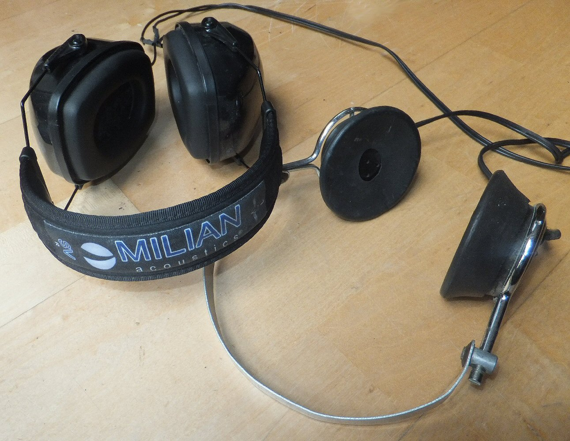
Low Z Milian SV noise reduction headphones and old style SG Brown high Z headphones

Typical ‘stereo’ or ‘walkman’ type headphones, although generally much wider band and 'better quality' then my old SG Brown high impedance phones, are not ideal for shortwave listening. Milian make studio noise reduction headphones, these are not noise cancelling headphones they are noise reduction headphones. They are basically workman's ear defenders which have been modified to contain quality earphones inside them. Over the years I have brought all three types: the travel set, the medium range and the studio quality phones for listening to music. The middle range phones turn out to have a superb response for SSB and are actually quite sensitive for low Z phones. The sound proofing properties of the ear defenders coupled with the perky response makes them one of the best headphones for shortwave listening I've come across.
I have often had problems with instability when using the popular LM380 audio power amplifier and find the LM386 is much more stable. The later provides easily enough power for a small loudspeaker or headphones. While we are in the subject of headphones don’t forget to put 56R resistors (or there about) in series with the headphones and the audio amplifier output. At first sight it may seem strange to do this (don’t do it to the loudspeaker circuit!) but they greatly reduces the background hiss you have to endure coming from the amp. Generally we are not aware of the speaker hiss but because the speaker inserts are so close to your ears when using headphone, the amp hiss is very noticeable. In practice the loss in audio from the series resistors is easily compensated by simply turning up the volume.

Noise on 80m band
The noise level on 80m has increased over the last 30 years. Even in the 80's I remember people wondering why I bothered with 80m saying it was too noisy for them. Back then most people didn't have PC's, broadband equipment or plasma TV’s. The main source of interference I experienced was from central heating systems going ON / OFF from the houses around me (and worse still, not quite going ON but arcing). This would start between 6 and 7am just when the dawn DX was coming through! You would get regular strong 'brrrrrr buuzzzzz' for 10 seconds of so, just enough to miss a DX callsign.
On my MK I receiver strong signal break-through from broadcast stations was sometimes a problem. Also in the 80’s there was an unusual strong recorded service broadcast near 80m which seemed to consist of a German woman endlessly counting out numbers in a loop. Correct setting of the balanced diode mixer could dramatically improve breakthrough problems (it took me years to discover this!). A decent home-made pre-selector and ATU provides a lot of front-end performance improvement for a simple DC Rx. Nowadays there is a lot of extra noise from plasma TV and switch mode power supplies, so for serious 80m listening a loop antenna is a must.

Antennas
Back in the 80's I used a balanced ATU and a full sized inverted V antenna (basically a dipole) for 80m at my parents home in Sea Lane, Goring. The apex was at about 35' while the ends went down to insulators at about 10' above ground. This was a good antenna. After leaving home I only listened on 80m when I was back for Christmas or other hols. I once tied a 1/4 and 1/2 wavelength length of wire onto a large helium balloon and used it to make an end fed vertical (with ATU and good earth). It worked but the noise was AWFUL! When I finally got a house in Brighton in the early 2000’s I started listening again properly on 80m, I then built the MK II DC Rx and, because I had no space for a full sized dipole, I also started to experiment with loop antennas.
The small ca. 50cm diameter 7 turn loop shown above is tuned using a ca. 300pf variable capacitor and a small single turn coil (just seen on the inner right of the loop) is used to provide a 50 ohm coupling. It works really well as a portable Rx antenna [4]. There is a nice null broadside to the plane of the loop and you can twist and turn the loop to reduced local interference. Sometimes you not only need to rotate the loop but also slope it at an angle it to get the best signal to noise. One night in Dec 2006 I used this to listen to EA9IE on the top end of 80m work a lot of Northern America and I could hear everything he could!

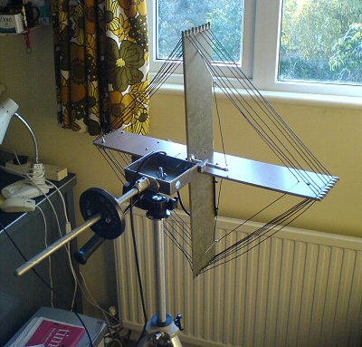
Small 50cm 7 turn receiving loop on a camera tripod with counter weight.
A triangular shaped single turn coil within the loop couples to 50 ohm coax.

I have also developed a larger, 4 or 5 turn loop (1m diameter) based on a ‘flat dwellers antenna’ design by Harry Lythall SM0VPO. This is a really great listening antenna [4]. The signal pick-up on a loop is somewhat less than on a full sized dipole, however the noise level is often much reduced, hence the signal to noise ratio is usually much better.

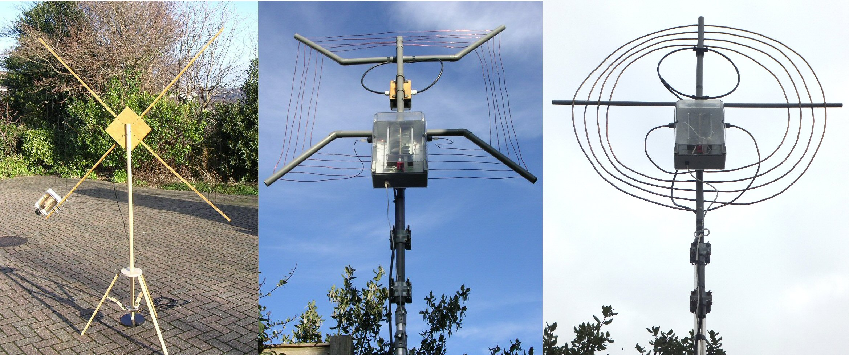
Development of a 1m diameter four / five turn loop for 80m: i) normal hook-up wire, ii) 12 SWG solid copper wire and iii) 8mm copper tube. The box contains the tuning capacitor, while the circular coil is a Faraday coupling coil to match to 50 ohm coax.

Over the last five years or so I have modified this loop in a number of ways. The original SM0VPO antenna (left hand photo) used standard muti-wire cable which worked well on receive. Later I swapped this for 12 SWG copper wire (middle photo) to see if it would improve the response. My latest version is made from a single piece of 8mm copper tube (left hand photo). I have tried Jackson variable caps, vacuum caps but now use a home-made wide spaced (8mm spacing between vanes) capacitor. If you use a double ganged capacitor (sharing the same shaft) you can connect the two ends of the loop to the fixed part of the two capacitors and only move the common tuning part. This way you don’t need any sliding contacts that might introduce noise and resistance losses.
The capacitor is fitted with a geared motor drive inside a water proof box fixed near to the base of the loop. The circular coil above it is a Faraday coupling coil to match into 50 ohm coax. A low VSWR (better than 1.2 : 1) is possible using this technique. At first I was a bit worried that the coil and capacitor might just be acting as a remote ATU to match the outer of the coax as a sort of ‘long wire’ antenna! But once a good match is obtained it does not seem to be effected by adding a random length of coax to the line so I am pretty sure the loop is really acting as the antenna! (the low noise and null is another clue its working ok of course).
You can see in the middle photo that I used a small water proof box for the wiring of the Faraday loop. Water always seems to get in though and I find it better to use heat shrink and tape directly on to the coax. For the capacitor and motor drive you have no other option.
With the 4 turn 8mm copper tube loop I hope to be able to use a few watts for low power SSB and PSK31 experiments (Yes, after all these years I will actually Tx on 80m!). Because the inductance is high I can easily make the small capacitor needed for resonance. A low value cap can be made very wide spaced to take high voltages.
According to the antenna pioneer, John Kraus, the radiation resistance of a small n turn loop (small compared to the wavelength) increases as n² while the ‘DC’ resistance (considering the skin effect) will increase as n. So there may be an advantage of a four turn loop over a single turn loop (I’ll let you know … work in progress).

Some key stations, moments and observations over the years
One morning in January 1987 I heard K1JJ (I heard him RS 56) using a 11 element yagi beam, 20m agl with a 300' boom on 80m! Presumably a wire beam??!
In 2007 I heard DJ9TK (Gustaff) calling in his very characteristic way. I realised that I had been listening to him for over 25 years on 80m band!
LX1UN’s station: 1000W, 30m vertical, 150 radials, FT1000D.
In November 2007 local stations were all very weak but the DX good. G3UCK (who is usually very strong) was the same strength as AA4MM. There was lots of fog over the UK at that time and I wonder if it was absorbing the ground wave?
18th February 2008 AA4MM still very strong even in broad daylight.
28th September 2009: 7J4AAL 56: using a 5 element yagi, 50m asl (!). Best signal from Japan.
G0EVY’s station: a full-size 80m beam on a 150' tower consisting of a 95' boom (7" diameter) with 126' long elements (4 1/2" tube diameter). The antenna weighs 1456lb and has 1000' of feed line!
15th December 2011 VY2ZM: using a 6 element array and was still 58 at 8:30am.
Oct 2013 ZL1BMW - really great signal from New Zealand.

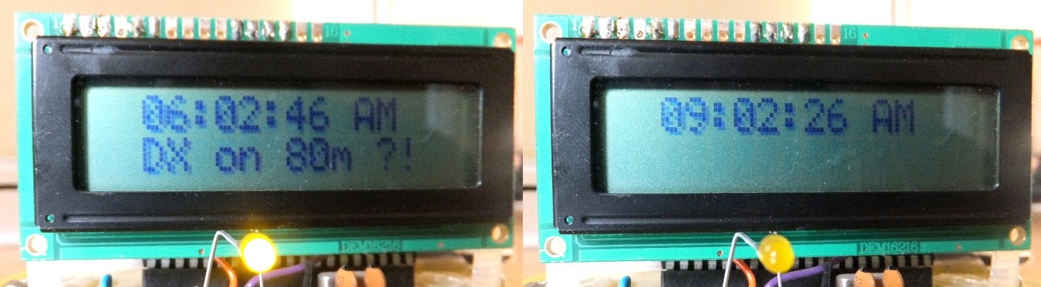
My 80m band PIC clock. Instead of an alarm that will wake-up everyone, an LED (and screen message!) lets me know if it’s time (6am to 8am) to get up and listen on the band.

An 80m clock
Getting up early to listen on 80m can be disturbing for our partners. If I set my alarm clock for 6am it will obviously wake both of us I won’t be in Sarahs ‘good books’! Sometimes I might set the alarm clock then in the morning just not feel like getting up early. So I devised a PIC ‘80m band clock’. Instead of setting-off an alarm it simply lights an LED between 6am and 8am. I am quite a light sleeper so if I naturally wake in the night I can tell if it’s time to get up (to listen to the DX!) as the LED will be ON after 6am. The LED gives enough light to read the LCD time and I get the 80m message to inspire me! My thinking is that if I don’t wake up at all, then I probably need the sleep but if I do see the LED light then I can decide if I want to get up or not!

Future projects
I am in the process of building a Cascode pre-selector to replace the simple single FET circuit I am currently using. This should provide more gain (ca. 20dB). Simply adding more gain to the input of a radio is not usually the best way of improving performance but on a DC receiver, where the main gain is in the audio stage, it can help the signal to noise rather than just raising the noise level of the whole set up. I am also working on an AGC circuit using a LM13700 trans-conductance amplifier. This will also mean I can experiment with a simple audio S-meter. Hopefully it will provide some large signal protection and audio levelling.

Operating style
The big guys at the top end of 80m have all got one thing in common - an impeccable operating style. It’s just a delight to listen to the skill, humour and politeness of these operators. On the whole I find people are still very obliging, patient and skilled on 80m. You sometimes get the odd ‘big station’ who does not say their call very often or the call of the DX station they are talking too - very frustrating for a short wave listener. At one time I wrote to a few of the DX guys and on the following mornings they made an effort to say ‘hello to any short wave listeners who might be listening’. That was a nice touch.

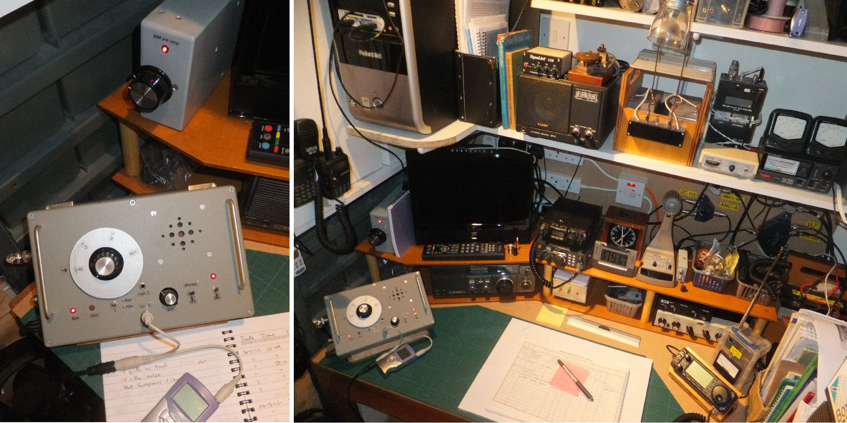
2013 G1EXG station. The MK II DC Rx is to the left of the photo.
The small Archos MP3 recorder is shown resting on the logbook.

A community on 80m
Back in the 80's the ‘top end’ of 80m was held by 'giants' such as GU3KFT, G3FPQ, EI8H, DJ9TK, M1XZ (San Marino). These stations often used delta loops or large vertical antennas so that you could hear them extremely strongly as well as the DX they were working. By the 2000's it was LX1UN, PA1K and ON1JW who where the ‘big guys’ in Europe. There was a lovely sense of community because you could hear everything – both the local and distant stations - you could hear the world! While most people were moaning about the end of summer I was looking forward to DX on 80m - it really ‘made’ my winter months and kept me sane at school.

80m today
The new 'net holders' are people such G3UCK, EI6S (George, who is fondly known to the rest of the world as 'the European beacon'), DF2BO, PA0GMW. Many of these are using four square antennas (an array of four or more 1/4λ verticals phased in such a way that they can direct their transmission / reception), beaming their signals out. Because of the local noise level in Brighton I sometimes have problems even hearing these 'locals' when they use some beam headings and depending on band conditions etc. Consequently some days there is not the feeling of community I used to get when everyone was audible. But these days are in the minority and I still generally look forward to my time listening on the top of 80m with all home-made gear.
In October 2013 I turned on to the top end of 80m at about 6 am to hear a amazingly strong New Zealand station ZL1BMW working a lot of UK stations on SSB including Jerry G0BRP from the WADRC who gave each other 59 both ways!

References and Notes
[1] A Guide to Amateur Radio, P Hawker, my version is the 17th Edition, 1978. ISBN 0 900612 43 6
[2] Radio & Electronics Cookbook, page. 261, RSGB, 2001. ISBN 0 7506 5214 4
[3] Improved Direct Conversion Receiver design, N. Hamilton, G4TXG, Radio Communication, RSGB, April 1991.
[4] For my loop experiments please see my web site at:
http://www.creative-science.org.uk/minihfloop.html
http://www.creative-science.org.uk/smallhfloop.html
[5] Also see my radio page at:
http://www.creative-science.org.uk/g1exg.html
[6] A latest up-dated version of this article can be found at:
http://www.creative-science.org.uk/80mDCRX.html

G1EXG, Jonathan Hare, October 2013

